PO9_Lakers

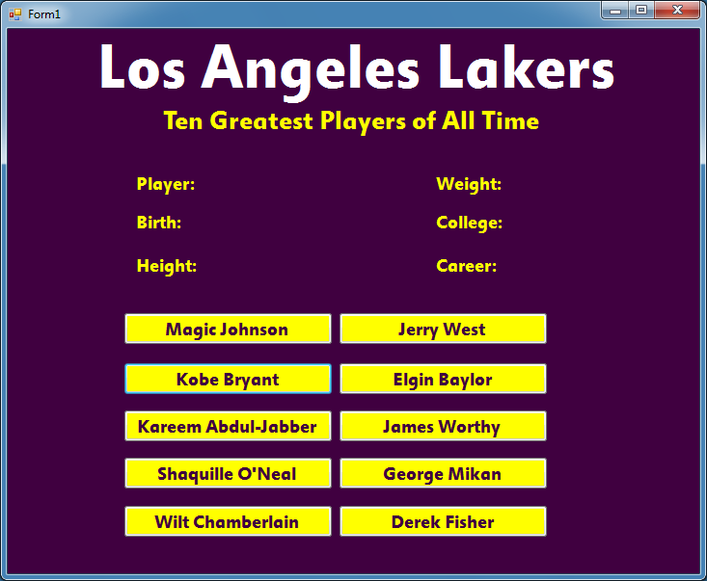

Private Sub btn4_Click(sender As System.Object, e As System.EventArgs) Handles btn4.Click

lblDisplay.Text = "Magic Johnson"

lblDisplay2.Text = "August 14,1959"

lblDisplay3.Text = "6'9"""

lblDisplay4.Text = "220 lbs"

lblDisplay5.Text = "Michigan State"

lblDisplay6.Text = "1979-1998"

End Sub

Private Sub btn2_Click(sender As System.Object, e As System.EventArgs) Handles btn2.Click

lblDisplay.Text = "Jerry West"

lblDisplay2.Text = "May 28,1938"

lblDisplay3.Text = "6'2"""

lblDisplay4.Text = "175 lbs"

lblDisplay5.Text = "West Virginia"

lblDisplay6.Text = "1960-1974"

End Sub

Private Sub btn1_Click(sender As System.Object, e As System.EventArgs) Handles btn1.Click

lblDisplay.Text = "Kobe Bryant"

lblDisplay2.Text = "August 23, 1978"

lblDisplay3.Text = "6'6"""

lblDisplay4.Text = "205 lbs"

lblDisplay5.Text = "n/a"

lblDisplay6.Text = "1996-present"

End Sub

Private Sub btn5_Click(sender As System.Object, e As System.EventArgs) Handles btn5.Click

lblDisplay.Text = "Elgin Baylor"

lblDisplay2.Text = "September 16,1934"

lblDisplay3.Text = "6'5"""

lblDisplay4.Text = "225 lbs"

lblDisplay5.Text = "Seattle"

lblDisplay6.Text = "1958-1971"

End Sub

Private Sub btn6_Click(sender As System.Object, e As System.EventArgs) Handles btn6.Click

lblDisplay.Text = "Kareem Abdul-Jabber"

lblDisplay2.Text = "April 16,1947"

lblDisplay3.Text = "7'2"""

lblDisplay4.Text = "225 lbs"

lblDisplay5.Text = "UCLA"

lblDisplay6.Text = "1969-1989"

End Sub

Private Sub btn7_Click(sender As System.Object, e As System.EventArgs) Handles btn7.Click

lblDisplay.Text = "James Worthy"

lblDisplay2.Text = "February 27,1961"

lblDisplay3.Text = "6'9"""

lblDisplay4.Text = "225 lbs"

lblDisplay5.Text = "North Carolina"

lblDisplay6.Text = "1982 - 1994"

End Sub

Private Sub btn10_Click(sender As System.Object, e As System.EventArgs) Handles btn10.Click

lblDisplay.Text = "Shaquille O'Neal"

lblDisplay2.Text = "March 6,1972"

lblDisplay3.Text = "7'1"""

lblDisplay4.Text = "325 lbs"

lblDisplay5.Text = "Louisiana State"

lblDisplay6.Text = "1992-2011"

End Sub

Private Sub btn12_Click(sender As System.Object, e As System.EventArgs) Handles btn12.Click

lblDisplay.Text = "George Mikan"

lblDisplay2.Text = "June 18, 1924"

lblDisplay3.Text = "6'10"""

lblDisplay4.Text = "245 lbs"

lblDisplay5.Text = "DePaul"

lblDisplay6.Text = "1946-1956"

End Sub

Private Sub btn15_Click(sender As System.Object, e As System.EventArgs) Handles btn15.Click

lblDisplay.Text = "Wilt Chamberlain"

lblDisplay2.Text = "August 21,1936"

lblDisplay3.Text = "7'1"""

lblDisplay4.Text = "275 lbs"

lblDisplay5.Text = "Kansas"

lblDisplay6.Text = "1959-1973"

End Sub

Private Sub btn16_Click(sender As System.Object, e As System.EventArgs) Handles btn16.Click

lblDisplay.Text = "Derek Fisher"

lblDisplay2.Text = "August 9,1974"

lblDisplay3.Text = "6'1"""

lblDisplay4.Text = "210 lbs"

lblDisplay5.Text = "Arkansas-Little Rock"

lblDisplay6.Text = "1996-present"

End Sub

End Class